**CATHOLIC BISHOPS’ CONFERENCE OF INDIA (CBCI)**

OFFICE FOR DIALOGUE & DESK FOR ECUMENISM

***CBCI Centre, 1 Ashok Place, New Delhi, India - 110001***

*Mobile: 091- 9849965958 Email:cbci.dialog.ecumenism@gmail.com*

==================================================================================

***Chairman*: Rt Rev. Dr Joshua Mar Ignathios, Bishop of Mavelikara**

***Members*: Rt Rev. Gerald John Mathias, Bishop of Lucknow & Rt Rev. Ivan Pereira, Bishop of Jammu-Srinagar**

***National Secretary*: Rev. Fr Dr Anthoniraj Thumma**

**=====================================================================================**

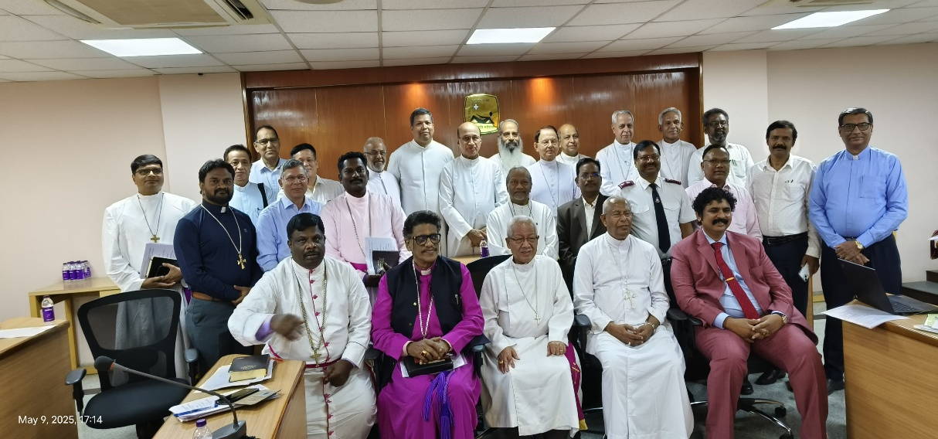

**PRESS RELEASE**

***National Federation of Churches Mooted in India***

The Catholic Bishops’ Conference of India (CBCI) convened the Second National Ecumenical Bishops’ Fellowship and Consultation Meetingon May 09, 2025, from 03.00 to 05.30 p.m. at St. John’s National Academy of Health Sciences (SJNAHS) Bengaluru. Around 35 Archbishops / Bishops, Church Heads, and delegates of various Churches and Christian Denominations participated in the Fellowship Meeting. Its purpose was to foster the unity and communion among the Churches and thus strengthen the ecumenical movement in India. It also included a consultation on theCBCI proposal of establishing a federation of Churches at the national level with the Presidents / Moderators / Metropolitans / Chief Heads of Councils / Synods of major Churches.

The Meeting began with the Opening Hymn, “We are One in the Spirit …”, and Ecumenical Prayer Service for Christian Unity adapted from the Resources for the Week of Prayer for Christian Unity for throughout the year 2025 jointly prepared and published by the Dicastery for Promoting Christian Unity of Roman Catholic Church (RCC) and the Commission on Faith and Order of the World Council of Churches (WCC). The theme chosen for 2025 is: “Do you believe this?” (John 11:26) to mark the 1,700th anniversary of the first Ecumenical Council held in Nicaea, near Constantinople, in 325 AD. During this Prayer Service, a prayer intention was raised for the victims of the ongoing conflict between Indian and Pakistan, and for return of normalcy and peace between them. After this, Homage was paid to Late Pope Francis, an ecumenical bridge builder, with a prayer led by Bishop Akhlesh Edgar, General Secretary of the Council of Evangelical Churches in India (CECI). The participants also prayed for the new Pope Leo XIV joining the prayer led by Rev. Lunmang Haokip, Executive Member of Council of Kuki Worship Services.

Welcome and Inaugural Address was given by Archbishop Mar Andrews Thazhath, President of CBCI, who emphasised the urgency of coming together and working together. He asserted that it is the need of the hour at the wake of increasing attacks on the Christians by the communal forces. The presentation of the Minutes of the last National Ecumenical Bishops’ Fellowship Meetingheld on September 13, 2024, was done by Fr Dr Anthoniraj Thumma, the Coordinator of the National Ecumenical Bishops’ Fellowship. It was followed by the Key-Note Address delivered by Bishop Joshua Mar Ignathios, Chairman of CBCI Office for Dialogue and Desk for Ecumenism, on the CBCI proposal of establishing a national federation of Churches comprising of the Bishops and Church Heads. It was taken up for deliberation in the Open House ecumenical dialogue by the delegates. While the need of a national ecumenical federation of the Bishops and Church Heads was accepted and affirmed by most of the delegates, it was felt that its guidelines needs to be worked out. Some also pointed out that its relationship with the existing national ecumenical bodies like the National United Christian Forum (NUCF) needs to be clarified.

In his concluding remarks CBCI President Archbishop Andrews Thazhath, who chaired the Meeting, summarised the consensus decision that there should be one national apex body and others could function as subsidiaries under its umbrella. It was also decided to hold some programmes to mark the Jubilee 2025 and the 1700th Anniversary of the First Ecumenical Council of Nicaea and Nicaean Creed on September 11 – 12, 2025 along with the next National Ecumenical Bishops Fellowship Meeting. After the vote of thanks proposed by Rev. Fr Anthoniraj Thumma, Secretary of the CBCI Office for Dialogue and Desk for Ecumenism, the Meeting came to a close by singing the hymn, “Bind us Together…” and the benediction given by Archbishop Andrews Thazhath. The Fellowship Meeting provided the joy of coming together as the disciples of the Lord Jesus Christ to the participants who were carried with them the experience of feeling “how good and how pleasant it is for brethren to dwell together in unity!” (Ps 133: 1)

*Reported by Rev. Fr Dr Anthoniraj Thumma,*

*Coordinator of National Ecumenical Bishops’ Fellowship &*

*Secretary of CBCI Office for Dialogue & Desk for Ecumenism.*

St John’s NAHS (SJNAHS), Bengaluru – 09-05-2025.

**REV. FR. DR. ANTHONIRAJ THUMMA, M.A. (Soc), M. TH., PH.D.**

National Secretary, CBCI Office for Dialogue and Desk for Ecumenism (CBCI-OD&DE)

Advisor, Federation of Telugu Churches (FTC)

Visiting Professor in Contextual Theology

--------------------------------------------------------------------------------------------

National Secretary, CBCI-OD&DE

CBCI Centre,

1 Ashok Place, Near Gole Dhakkana

New Delhi – 110001.

Mobile:  098499 65958

E-mail   : <[arthumma@rediffmail.com>](mailto:arthumma@rediffmail.com)

<cbci.dialog.ecumenism@gmail.com>

<http://www.globethics.net/web/19064432/~/13227565>

[https://www.facebook.com/Federation-of-Telugu-Churches-FTC](https://www.facebook.com/Federation-of-Telugu-Churches-FTC-106443040781356)

https://independent.academia.edu/anthonirajthumma