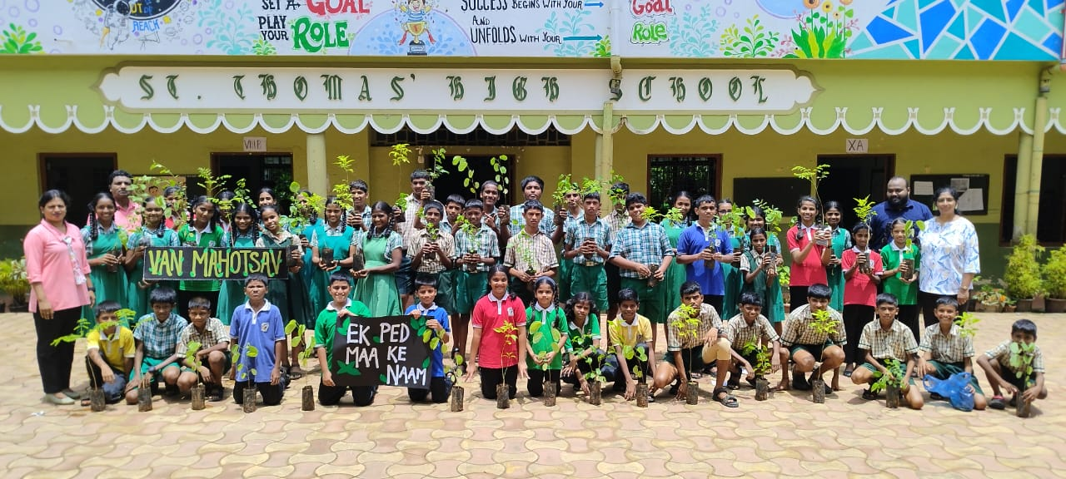
VAN MAHOTSAV CELEBRATION AT ST. THOMAS HIGH SCHOOL.
Van Mahotsav was joyfully celebrated at St. Thomas High School on 10th July 2025. The morning assembly highlighted on the theme “Ek Ped Maa Ke Naam”, showcasing the significance of trees through a meaningful skit, graceful dance, and inspiring speech. Students took an innovative step by generating QR codes emphasizing the benefits of various plants, which were then tagged to the saplings by Headmistress Jacqueline Noronha and Primary Teacher In-charge Etelvina Gonsalves. A creative and colourful wallpaper was prepared by students of grade IX.

As part of the celebration, a kitchen garden was inaugurated, where the Headmistress, Science teachers, and students came together to sow seeds. On this occasion, the Forest Department distributed saplings to the students, motivating them to plant and nurture trees. The entire event was organized by the science teachers to instill environmental awareness and responsibility.

Van Mahotsav Celebrated at St. Thomas High School
St. Thomas High School celebrated Van Mahotsav on 10th July 2025 with the theme “Ek Ped Maa Ke Naam”. The event featured a skit, dance, speech, and QR-coded saplings tagged by the Headmistress and staff. A kitchen garden was inaugurated, and saplings were distributed by the Forest Department. Organized by the Science Department, the celebration aimed to promote environmental awareness among students.

